Bessemer Board Of Education

Office of Business Affairs and Finance

1621 Fifth Avenue North
Post Office Box 1230
Bessemer, Alabama 35020
Phone: (205) 432-2930 Cell: (205) 478-2832 Fax: (205) 432-3085
E-mail: pstewart@bessk12.org

Pat Stewart
Chief School Financial Officer

BESSEMER CITY HIGH SCHOOL BAND UNIFORM BID

PUBLIC NOTICE FOR INVITATION TO BID ON A TOTAL OF 100 HIGH SCHOOL BAND UNIFORMS FOR BESSEMER CITY HIGH SCHOOL. Sealed bids must be received by the Bessemer City Board of Education on the following bid date and time: __________________, 2020 at_______. The Bid Opening will occur at _____on _________________, 2020. This project shall be bid excluding taxes. The bids must be submitted on company letterhead and the company name, bid number, and proof of insurance are to be posted on the outside of the bid envelope. **This is required for the bid to be accepted and opened** No bid may be withdrawn after scheduled closing for receipt of bids for a period of sixty (60) days. The Owner reserves the right to reject any or all proposals and to waive technical errors if, in the Owners judgment, the best interests of the Owner will thereby be promoted. A separate certified check or Bid Bond payable to The Bessemer City Board of Education in an amount not less than five percent (5%) of the amount of the bid, but in no event more than $10,000.00 must accompany the bidder's proposal. Sealed bids will be received by the Bessemer City Board of Education, 1621 5th Avenue North Bessemer, Alabama, 36020, and publicly opened and read aloud for band uniforms in the central office board room.
The project shall be bid excluding taxes. No bid may be withdrawn after scheduled closing for receipt of bids for a period of sixty (60) days. The Owner reserves the right to reject any or all proposals.
Questions may be directed to Patricia Stewart, CSFO, at 205-432-3029 or pstewart@bessk12.org.

Owner:
Bessemer City Board of Education
1621 5th Avenue North
Bessemer, Alabama, 36020

INVITATION TO BID
Your company is hereby invited to submit a BID QUOTATION ON THE ITEMS AND QUANTITY, AS DESCRIBED FURTHER IN THIS WRITTEN INVITATION. PLEASE RETURN THE bid form page(s) with your official bid. If you are unable to submit a bid quotation at this time, and if you wish to remain on our list of potential suppliers, simply send us a written explanation.
The deadline for our receipt of your bid is: ______________________________, 2020.
Whereas considerable time and expense has gone into the preparation of the enclosed specifications, deviations are NOT anticipated. DEVIATIONS MUST BE DOCUMENTED. Unless fully documented, such deviations may DISQUALIFY a bidder at the discretion of the BUYER.
In setting forth these specifications it is the intention of the buyer to offer equal opportunity to all bidders. Styles referred to by number and the company name are for descriptive purposes only and are not restrictive. The buyer feels that specified styles, material, linings and sundry items are equally available to all reputable manufacturers.
Bidder is to furnish itemized quotations showing the cost of each item, the total price per uniform, and the total price of the entire order. Any allowance or cash discount for payment within a certain period before or after delivery is to be indicated on the bid; otherwise, it is presumed that payment is to be made on the basis of net 30 days.
The buyer reserves the right to accept or reject any or all bids in the best interest of the buyer. Factors to be considered when determining the best value for the buyer are to be quality of the garment, service and responsibility of the company and their representative, as well as price. Low bid is not necessarily to be awarded the contract.
Bidder is to furnish a full time sales representative to handle all details of the order. This includes measuring and servicing, "after the sale". Bidder is to provide name, address and phone number of representative or representatives who are to be responsible for handling the order.
In submitting your bid, specify the time required for delivery of the complete order after receipt of all details.
SAMPLES (EXACT)
A. All bidders must submit an exact sample uniform together with their proposals. This sample uniform must be in the same color as the uniform proposed; it should reflect the exact style, and must reflect the tailoring details as would be found in the uniform being proposed, and of the uniform which would be furnished if awarded the Contract by the Buyer. Where special construction features are specified, these must be furnished with the bid showing the manufacturer’s version of the feature. All major items being proposed must have a sample presented for comparison. It is to be completely understood that it is the intent of the Buyer to have all items examined carefully and compared by persons conversant with quality for evaluation of internal components.
B. All bidders must submit liberal sized swatches of the materials to be used in the final product in the color and mill-weight as listed in the Uniform Specifications. The buyer reserves the right to inspect the workmanship of the sample, its inner construction in particular, and for this purpose will open the lining if necessary.

SPECIFICATIONS

- GENERAL
Coats, trousers, blouses and all major parts of the uniform are made to fit the nearest stock size from the information supplied by the company representative. This is done for a better year to year fitting program and allows more fitting flexibility. Exceptions are made on unusual sizes wherein the garment is cut and produced to the measurements taken by the company representative.

- LABOR
All garments must be UNION made and shall include the union label. This is to insure consistency and uniform of the manufactured goods. Uniforms made otherwise may have a tendency toward sloppiness and unprofessional tailoring, due to the unskilled cutting and sewing operations.

- SHIPPING
Uniforms are to be shipped on wishbone style hangers. Hangers are to be hard plastic, not wood. Wooden hangers have a tendency to pick and pull the basic fabric, and they are not acceptable. The hangers must be bent and rounded at the top to allow the shoulder area of the garment to be spread and hung properly. Each uniform must be delivered in its own clear polyethylene bag to prevent soiling. Uniforms must be delivered in 200 lb. Test cardboard wardrobe containers, opening from the front, and having a metal bar reinforcement at the top with clasp to prevent hangers from disengaging from the metal structure. Each carton will be properly marked on the outside, with identification numbers of the uniforms contained in that specific carton.

- IDENTIFICATION
Each major garment item is to have identification numbers sewn into the individual pieces to allow for quick and easy issuing. Coats, trousers, and blouses are to have woven numerals. Trousers are to include inseam and waist information for future reference; coats shall have chest size and length indicated on a linen ticket. The original order is to include a bound booklet with the numbers of each uniform corresponding to the particular size of that uniform, arranged from the smallest to the largest. Size information shall include chest size, height, weight, and inseam for each uniform. Bound in the identification record shall be a size chart for use as reference for purchase of future uniforms.

- INSPECTION
All garments are to be carefully inspected before final packing and shipment. All thread ends to be picked and cut and specifications, trim and details to be critically checked for each individual garment before shipment. Buttons to be applied and sewn at that time.

- VERIFICATION OF FABRIC PROCESSION
Any dacron/wool blend fabric from any vendor must be professional cold water and alcohol
sponged, decated, and inspected. Bidder must submit in writing, certification that dacron/wool blend fabric will have undergone this fabric stabilization prior to manufacture of the uniforms. Also, such certification should be submitted in writing by an officer of the bidding company.
The company actually performing the stabilizing process must be indicated, with an individual or officer of said company to contact for verification of processing. As dacron/wool garments having not undergone such processing can experience significant and excessive shrinkage, bidders not providing such a sponging treatment and certification in this bid will be disqualified.

- SUSTAINABLE VERIFICATION CERTIFICATE
Any 14 oz Polyester fabrics must be certified by UTrust Verification Program and must be made from ECO-FRIENDLY textile products, developed from sustainable fibers. An UTrust Verification Certificate must be attached to this bid or RFP Solicitation. This certificate must be signed by an individual or officer for UTrust.

COAT SPECIFICATIONS

1. GENERAL

Due to the unique requirements of a band coat (relative to the number of different wearers, minimum care received, wearing conditions and life expectancy), special patterns, materials, design and construction methods must be applied. These specifications speak directly to the requirements of construction, which allow for professional washing OR dry cleaning of the garment.

2. PATTERNS

A. Coat patterns are special band uniform patterns with additional “ease” to allow for freedom of movement, wearing of clothing underneath and the convenient re-issue from year-to-year. Fashion or standard patterns do not allow enough room. Merely up-grading to oversized patterns will result in an unsightly and cumbersome fit.

B. Computer generated patterns will provide proper fit for all male and female band members, with no restrictions or limitations as to chest size. Likewise, sizes will be assigned in needed “lengths” from XXS through XXXL. Coats will be patterned for EACH even numbered chest size (ex. 38, 40, 42, etc.), rather than just generic S, M, L, etc.

C. Patterns are to be marked and graded using a computerized system to insure accuracy and updated patterns.

3. SIZING

A. Measurements will be taken under the direction of a factory-trained representative.

B. Sizes are analyzed by a sizing computer system assigning the closest standard proportion size to each wearer in order to permit re-issuing in subsequent years and to provide a reasonable fit for the initial wearer.

4. FABRIC

A. The shell fabric is Xtreme Dri polyester/synthetic, providing enhanced air permeability that differentiates it from generic polyester fabrics.

B. Xtreme Dri lifts moisture away from the wearer, which keeps the body cooler in warm weather and warmer in cold weather. It is stain resistant, tear resistant, odor resistant, quick drying, colorfast, and will not pill. Xtreme Dri is different than the standard polyesters that have been available to the band uniform industry, including, but not limited to 1933 (a.k.a. 4892), 420, 960, 6248, 4030 and 460. Standard polyester fabrics are not acceptable substitutes for Xtreme Dri.

C. Since Xtreme Dri is a proprietary exclusive fabric, any vendor may bid on what they consider their best available polyester for the project. However, any and all deviations must be thoroughly documented.
5. LINING

A. Coat linings are cut from a separate set of patterns designed to fit each specific coat size and style. Linings are not cut from coat shell patterns then cut down to try and fit.

B. Linings are “FIRST” quality Aerocool polyester/taffeta 97GR/Yd, woven to absorb and evaporate moisture rapidly by capillary effect. The absorption, diffusion and evaporation system of this lining is designed to maintain cool body temperature and excellent comfort for the wearer.

C. In coat styles that do not utilize a back zipper, the coat lining has a vertical pleat running up the center back. This allows fullness, fit and comfort to the overall performance of the coat.

D. In the armhole area, the coat lining is machine stitched to an ensemble including the outer coat fabric, shoulder pad and sleevehead. Hand sewing or felling does not provide the durability required for armhole construction.

E. Linings are sewn to the coat bottom edge, and reinforced with pre-shrunk tailoring tape. Straight cut long coats will have an additional ½” lining pleat all around the coat bottom.

6. BRAID (see #25-B)

Only first quality washable braid shall be used for trim. Braid trim ¼” or wider, is sewn down with two rows of stitching on looped trims as well as straight line. In addition, looped trim is reinforced with a layer of non-woven fabric, permanently bonded to the inside coat fabric surface to inhibit puckering tendencies.

7. BUTTONS

High-quality, rust resistant metal buttons shall be used where specified and they shall be attached by sewing, ring and washer or toggle and washer or tack-back. The buttons shall not alter the washable capabilities of the garment.

8. BUTTONHOLES

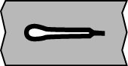
All coat buttonholes are made with a CUT-FIRST automatic buttonhole machine. The hole is cut first, the edges covered with gimp, then completely sewn to “close” the buttonhole. The buttonhole back is secured and closed with bartack reinforcement.

9. ZIPPERS

A. The style is YKK, heavy duty of color matching VISLON. The zipper is auto-locking and has a “separating” feature for maintenance and durability.

B. Zipper tapes are standard 9/16” width, sewn down with locked safety stitching and bar tacked at each end.

10. INTERLINING

A. The interlining has optimum four-layer construction. More than four layers create stiffness in the coat fronts, resulting in difficult and uncomfortable arm lift maneuvers in marching bands. Less than four layers results in flimsy construction and therefore a rumpled appearance and reduced durability. In keeping with individual patterns for coat shell fabrics and the linings, higher quality control and an elevated level of haircloth quality is obtained by these multi-layered interlinings being patterned, cut and assembled “IN HOUSE” at the uniform manufacturer’s facility. This basic construction practice enhances the fit and comfort of the individual uniform (as opposed to “making do” by purchasing these multilayered ensembles and cutting them down to fit the “hundreds” of patterns required for each coat style and chest size).

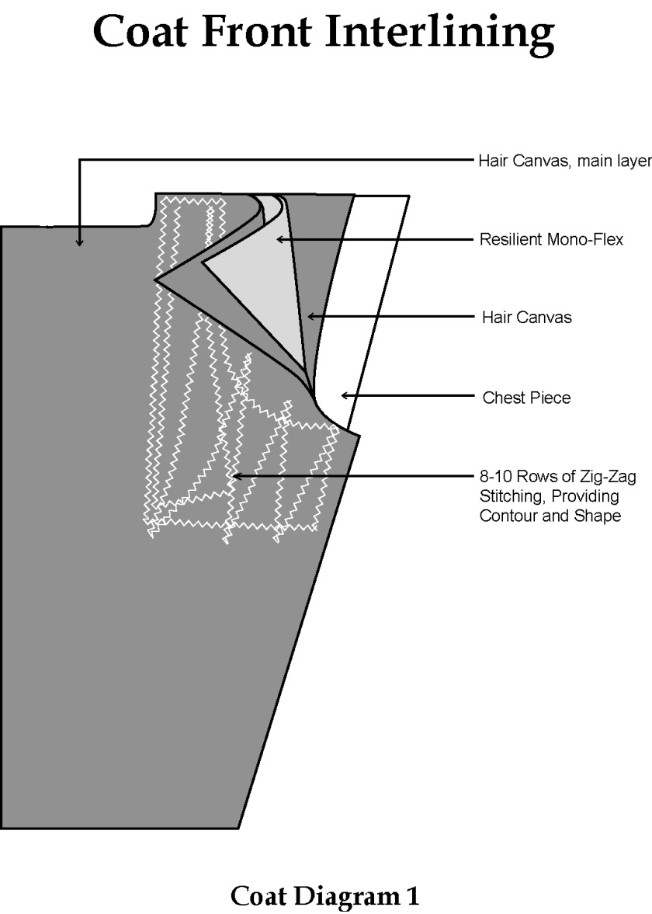

B. The main layer of the interlining is a Hymo haircloth. This “hair canvas” is a blend of polyester, viscose rayon and genuine natural hair, which gives it soft resilience. This canvas is 100% washable with no shrinkage or loss of rigidity. The layer extends the complete length of the coat front, from shoulder seam down to the coat bottom.

C. The second layer is a resilient 27.6% rayon/72.4% polyester canvas “MONO-FLEX” chest piece 4.2 oz in weight. Its dimensions are 6” wide x 6 ¾” long and extends downward from the upper chest area.

D. The third layer is another piece of hair canvas (as per “B” above) 8” wide and 12” long, extending downward from the upper chest area, and completely covering the MONO-FLEX.

E. The fourth layer is a ¼” thick padding of 3.6 ounce 100% polyester non-woven material that is soakable and non-shrinkable. This white chestpiece pad extends approximately 6” below the armhole.

NOTE: In white coats and other light color fabric shades, a piece of thin Poly-sil white curtain is added to prevent “shadowing” of the haircloth interlining through the outer coat fabric.

F. This entire multilayered interliner shall be sewn together with a series of eight to ten rows (depending on chest size) of zig zag stitching spaced approximately 1” apart. This is the optimum number of rows as recommended by the garment industry standards. Too many rows will reduce the flexibility, comfort and fit. Too few rows will limit durability and lifetime.

G. The interliner is then secured to the coat shell fabric and coat lining, in the neckhole, armhole, bottom front and along the coat closure edge. A tailoring tape of 100% PIMA cotton, triple cold water shrunk, is included in these seams for added durability. The interlining is NOT sewn into the shoulder seam, nor the side of the coat. This allows flexibility and “give” to the entire coat front construction.

NOTE: The above construction is a time proven procedure. Under no circumstances are the haircloth and sewing operations to be substituted with a fusing or gluing operation.

11. ARMHOLES

A. Armholes shall be oval shaped and allow sleeve to be pitched forward 3-4 degrees to maximize comfort and ease of movement with minimum distortion to the coat.

B. The armhole shall be reinforced with ¼” pre-shrunk cotton tape all around to prevent stretching in the armhole.

C. The entire armhole shall employ machine lock stitching. Hand or machine “felling” will not be accepted.

D. The underarm portion of the armhole will have a bi-swing gusset allowance that allows freedom of movement.

12. SHOULDER PADS

A. Shoulder pads shall be high quality foam, covered all around with a lightweight polyester lining, serge stitched around the curvature of the pad and are washable or dry cleanable.

B. Shoulder pad size shall be minimum of 5” x 9” on regular width coat styles.
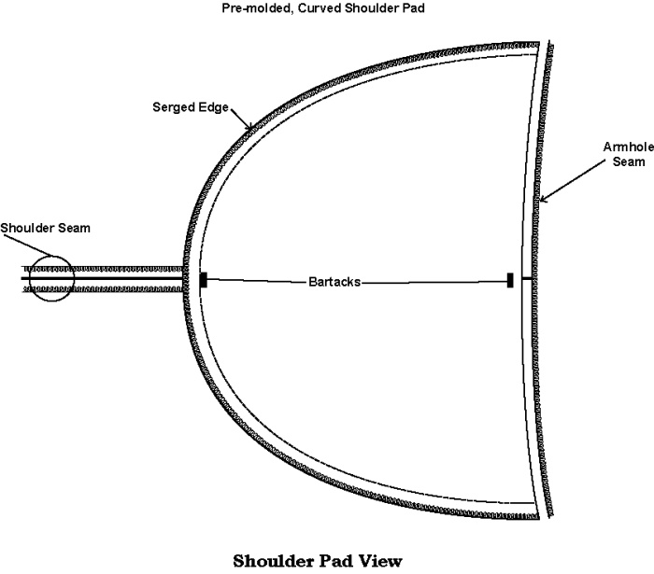

13. SLEEVE HEADS

The sleevehead provides fullness and shape to the top of the sleeve as it is sewn to the coat body. It consists of a separate strip of material used for the white chest piece pad in the interlining (10E). The sleeve head has a length of 14” and is equally positioned over the shoulder, to the front and back of the upper sleeve seam. The finished width is 2 ¼” at lower front, and tapers to a 1 ¾” width at lower back. The construction consists of a ¾” turnback on the armhole edge, and has a seam spaced ½” from the edge. Sewn into the lower front portion of the white pad strip, is a 2 ½” x 4 ½” piece of “haircloth” as described in the Interlining section (10B). The result of this “IN HOUSE” manufactured sleeve head is a substantially improved “body” in the entire sleeve/shoulder area, particularly when lettering or other embroidery trim is specified.
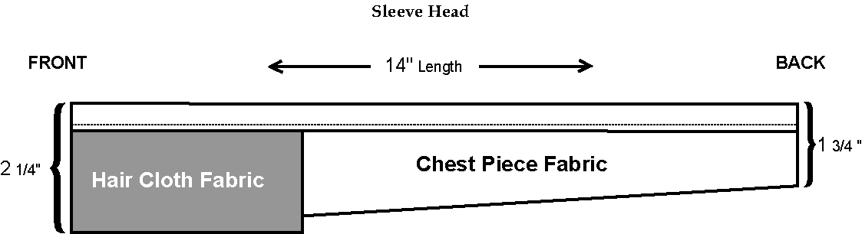

14. SLEEVE STITCHING

A. Sleeves shall be set with machine lock stitch to insure proper distribution of fullness and durability.

B. Fullness shall be sheered in by top-feed sewing machines.

15. ARMHOLE LINING FINISH

A. The bottom of the sleeve armhole shall be lock-stitched through two layers of lining, two layers of fabric and armshield.

B. The top shall be sewn through the coat lining, sleeve fabric, sleeve head, shoulder pad and shoulder strap with lock stitching.

C. The entire armhole has tailoring tape all around.

D. “Felling” by hand or machine is not acceptable when closing the armhole.

16. TAPING

A. All seams in high stress areas are reinforced with tailoring tape to prevent stretching, and add durability to the seam. These tapes are pre-shrunk.

B. Areas of this taping procedure include the following:

1. All around the neck opening where collar joins the coat.
2. Coat closure edges and completely around the bottom.
3. Complete circumference of the armhole.
4. Shoulder seams from collar (neck opening) to sleeve seam - except canopy coats.
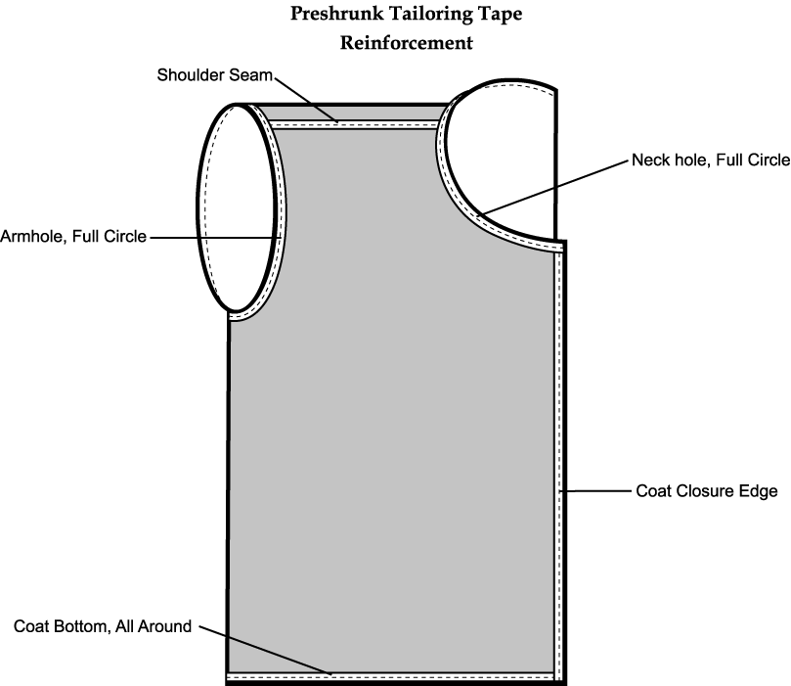

17. POCKETS

A. All inside pockets shall be constructed with a pocket welter and shall be reinforced with a non-woven fabric.

B. Pocketing material shall be 80/20 poly cotton, 100% poly fill, pre-cured finish, 3.05 YPP, 78/54 twill weave.

C. Upper and lower welts of the inside breast pocket are to be 100% polyester material and pellon backed.

D. Pocket bag shall be constructed on one piece of pocketing with no open seams at the bottom.

E. There shall be a tack at each end of pocket opening through all layers of pocketing. Tacks shall be concealed.

F. Pockets made of lining or lightweight material shall not be acceptable.

18. SLEEVES

A. Sleeves cuffs will have an approximate 4” turn up, which incorporates both the coat sleeve fabric and lining. This turn back includes a 3/8” binding at lower cuff edge.

B. The forward and trailing sleeve seams in the 50/50 sleeve pattern are equipped with a series of gripper snap rings and post hardware. Two posts, spaced 1” apart, are applied to the lower sleeve cuff edge, at both seams in each sleeve. Six ring style fasteners are positioned starting 2 ½” up from the cuff edge and are spaced 1” apart. Coats are shipped fully steam pressed, but without a crease at sleeve cuff bottoms.

C. Sleeve cuffs with extensive cuff trim (appliques, inserts, looped braid designs, embroidery) are reinforced with non-woven material, bonded permanently to the inside of the coat fabric extending up toward the elbow area. This addition prevents puckering tendencies created by use of fabrics, braids, etc. which each have a different coefficient of stretching.

D. Shoulder lettering and embroidered logo trim have a reinforced backing layer on the inside of the sleeve.

19. ARMSHIELDS

A. The armshield is engineered to minimize the long-term effects of perspiration over the lifetime of the garment. Perspiration consists of moisture, salts, weak organic acids and body oils. Xtreme Dri fabric having WICKING properties is specified for use as the armshield. (“Felt-like” fabrics that retain perspiration are not in the best interest of the garment). In addition to the wicking property, this Xtreme Dri shield has soil release, high permeability for airflow, and exhibits rapid evaporation.

B. The armshield is approximately 4” x 4” in dimension, bound with double folded bias rayon on both sides and the bottom, then machine sewn into the armhole.

C. Tensile strength and resistance to abrasion are additional advantages of Xtreme Dri armshields as compared to a “felt-like” material. The minimum abrasion quality is 10,000 on the STROLL FLAT test.
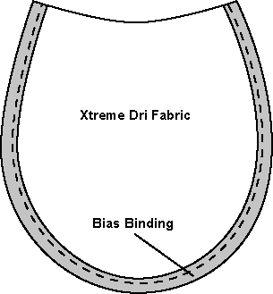

20. SHOULDER STRAPS

A. Both the upper and lower layers of the shoulder strap are interlined with permanently bonded, non-woven material. This four layer ensemble is secured with an inside hidden stitch then top-stitched all around the edge, set in approximately ¼”. These layers are die-cut to insure exact conformity in shape and size, throughout the lifetime of the garment.

B. Buttonholes are the CUT-FIRST style, having all raw edges reinforced with gimp, then solid stitching as described earlier in the Buttonhole section (item 8).

21. STANDING COMFORT COLLAR

A. The collar is one of the highest stress areas in the coat. The collar is cut from a curved pattern. This allows a front “drop” to fit the downward front slope of the natural human body configuration. This item is NOT to be cut in a straight pattern.

B. There are a total of eight layers in this comfort collar construction.

1. The collar lining of Xtreme Dri fabric, as described in the fabric section (item 4), has a non-woven material, permanently sewn and bonded to the inside.
2. Sewn directly to the inboard surface of this tandem collar lining construction, centered on the lining and running the circumference of the collar are two layers of 3/8” horse hair braid reinforcement.

3. The outer collar shell, also made of Xtreme Dri, has a non-woven material permanently sewn and bonded to the inside.

4. Both the collar lining construction and the outer collar shell construction are sewn to two base layers of heavy duty Pellon forming the finished comfort collar.

NOTE: The entire sewing operation in the construction of the collar is “machine-sewn”. Hand sewing simply cannot insure the required durability.

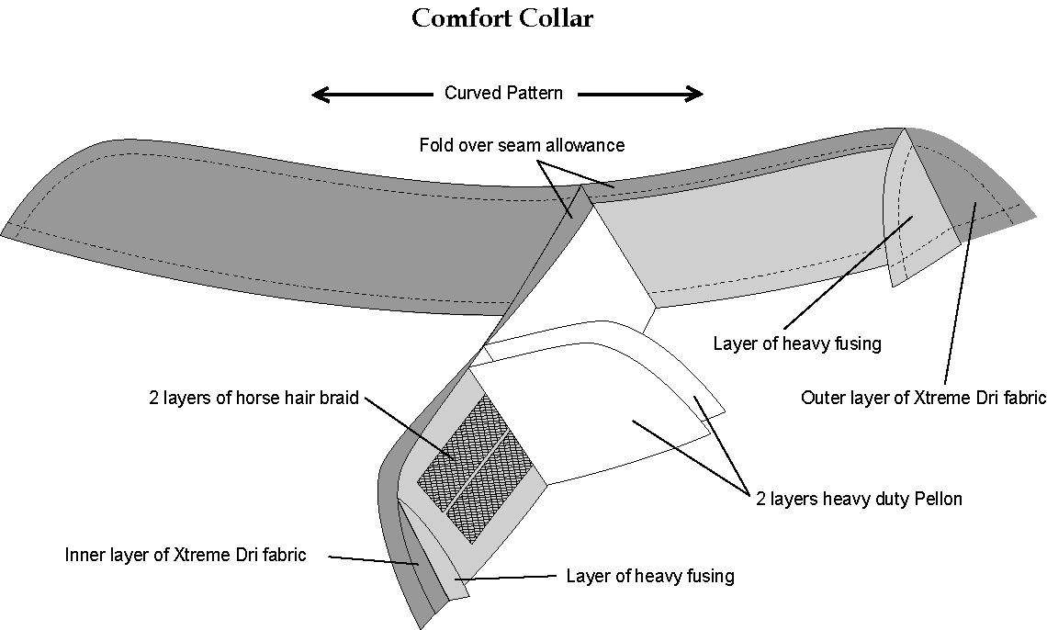

22. “WRAP” COAT COLLAR

The standing collar on the wrap style coat is “soft”, in that there is no inner layer of stiff mylar. This collar generally measures 1 ¾” finished width. The inside lining is Xtreme Dri fabric having a permanently bonded layer of non-woven fabric to reinforce the collar. The outer layer of the collar is also Xtreme Dri fabric having a reinforcing layer of monoflex (resilient canvas of 27.6% rayon/72.4% polyester – 4.2 oz. weight) stitched in. This results in a reinforced “soft” collar having four layers. All exposed edges are turned inward with an invisible row of stitching. A visible row of topstitching is added all around the edge. There are no exposed, rough edges.

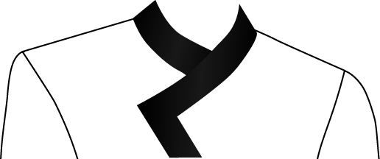

23. COAT TRIM

A. All trim must be sewn to the outer coat fabric before the lining and interlining are joined to the coat. Trim sewn through the interlining and lining is not acceptable.

B. Washable braid trim of ¼” or wider is sewn down with two rows of stitching. This includes looped trims as well as straight line. In addition, looped trim is reinforced with a layer of non-woven fabric, permanently bonded to the inside coat fabric surface, to inhibit puckering tendencies.

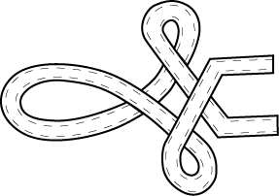

24. SPECIAL COAT STYLES

A. Seamless canopy coat styles will require a “Memory Recovery” system across the upper back and shoulders due to the under construction across each shoulder.

B. The Memory Recovery system is a 2 ½” wide panel of heavy duty light weight elastic, made of 90% (70 denier) nylon and 10% (140 denier) Spandex. It is sewn into each sleeve seam in the coat back area, and extends fully across the coat back. When the wearer of this coat style is in an arms down position, the system is relaxed. During an arm lift maneuver the entire coat back experiences stress and pulling across the shoulders. The Memory Recovery system brings the various fabrics, folds and coat parts, back to the original “EASE” position when arms return downward. This entire process prevents unsightly bulging. The durable elastic panel is included in the manufacturer’s warranty.

25. SEAMS

The center back seam and side body seams shall be 5/8”. Seams are to be plain with a minimum of 1 ¼” - 1 ½” total outlet in the side body seams and ¾” in the back seams. Coat is to be completely machine stitched except in areas where tailoring or appearance necessitates other methods. The ends of all seams and stitching shall be back-stitched not less than ¼”. Thread breaks of all stitch types must be secured by stitching back from break ½” to 1”. Coat is to be tailored with a four-piece back, comprised of a center back seam and two additional back body seams curving from sleeve seam downward and running out the coat bottom.

26. THREAD

Threads used throughout the garment will be TEX 40 size, 29/2 gauge and 4.56 lb. tensile strength. All threads used are to be heat resistant, vat dyed, sunfast, dry cleanable pre-shrunk and moisture proof. In areas of multiple color trim panels, a monofilament thread may be indicated. This thread is a 330 denier and has a .008 diameter rating. The manufacturer’s warranty includes all threads used throughout the uniform construction.

JUMPSUIT SPECIFICATIONS – AQUABILITY

- GENERAL

Jumpsuits are special marching band construction and design. They shall not employ fashion tailoring techniques, materials and patterns that will not withstand the rigorous end use of band uniforms. Fashion pocketing, waistband material and construction, lightweight snaps and hooks are not acceptable.

- PATTERNS

- The patterns and style must be in keeping with the end use of marching, with maximum capability to be adjusted for fitting a variety of wearers from year to year.

- They must have ample room for movement and be nonrestrictive for marching, in the seat, thigh and ankle area. The dimensions of a jumpsuit for a 38 regular male, shall not be less than 18” circumference at cuff and 23” at thigh.

- FRONT CLOSURE

- The fly zipper is brass “Y.K.K.” with a double locking slide. There is a metal stop at the base of the fly zipper. The fly teeth will extend completely up to the top of the waistband.

- The outside fly consists of the outer shell fabric and an inner layer of shell fabric.

- The inside fly is constructed with the zipper tape sewn flush to the edge

- CROTCH REINFORCEMENT

- There is a “four-way “ crotch reinforcement consisting of 80/20 poly cotton, 10% poly fill, 3.5 yard per pound, pre-cured finish fabric.

- There are four, two ply sections, one on each side of the intersection of the fly, seat seam and inseams.

- Crotch area is clean finished with no pieces extending from top of inseams.

- POCKETS

- Pockets are made of the outer shell fabric, and are a lateral extension of the zipper fly facings on both sides of the front fly. There are two front pockets in each jumpsuit/bibber trouser.

B. The pockets are 4” – 5” wide. The pocket depth is 7 ½” along the front fly edge, with a diagonal opening of 5 ½”. The lateral pocket depth is 4”.
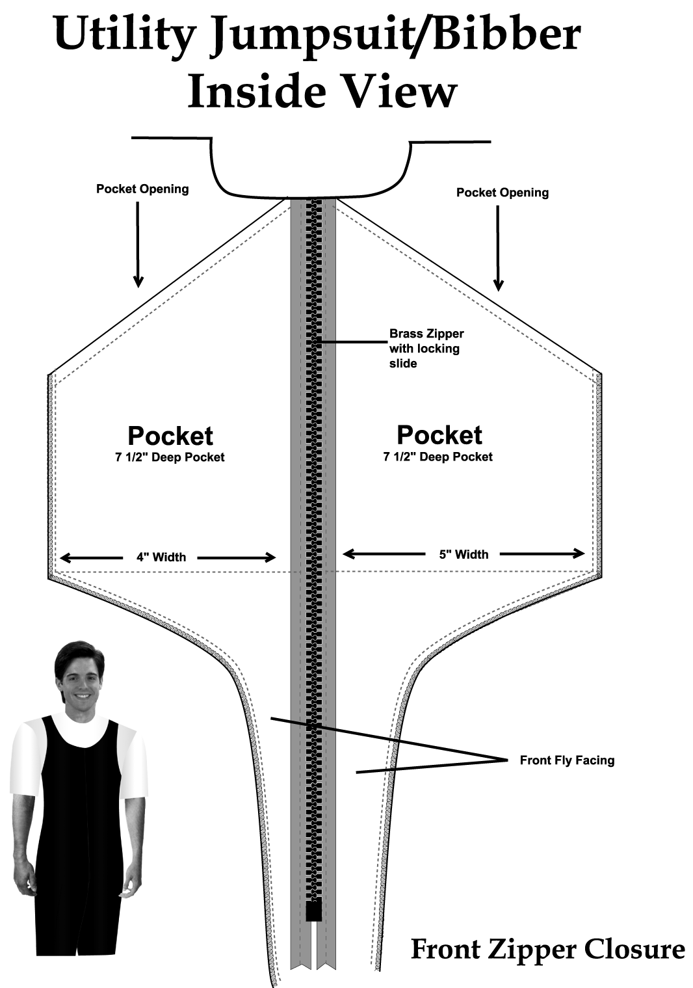
- INSEAM

- The trouser is unhemmed, with the bottom edge finished all around in a serge stitch.

- The inseam will allow ample length for a cuff hem, and is constructed with a flat seam having a 1” outlet.

- SEAMS

- The center back (seat) seam is finished using two rows of locked chain stitching for seam strength and durability. It is a flat seam with a 2” outlet.

- The outseam is secured with a safety double seam stitch.

8. PERMANENT SUSPENDERS

- Suspenders are made of whipcord fabric. Color shall match jumpsuits. Nylon webbing shall not be used because the adjusting slide will not remain in set position under tension from movement.

- Suspenders are two-ply, topstitched, and have interlining for body. This will insure the adjustable slide remaining in set position; suspenders will launder or dry clean as well as the jumpsuit.

- All hardware is unbreakable nylon as used in parachutes and life vests; unbreakable, unbendable and not subject to tarnishing or rusting. It will not cause undue abrasion on jumpsuit during dry clean tumbling.

- Suspenders are self faced and interlined with pellon. Lining of belting or pocketing is not acceptable.

9. PERIMETER SERGING

- All exposed “raw” edges are finished with a serging stitch of no less than 10 per inch, tight to edge, to prevent fraying.

B. Serging thread is polyester.

SHAKO, HELMET AND BAND ACCESSORY CARRY CASE SPECIFICATIONS

Headwear carry case is “Shako-Mate” or equivalent.

MATERIAL: High Impact Polystyrene. This material is heat resistant, which prevents
melting, and cold resistant, which resists breakage due to the material becoming brittle.

SIZE: 12” by 12” to accommodate headgear and plume as well as various accessory
items. Smaller boxes that prevent plume and accessories from being stored are not acceptable.

HANDLE: The handle is rounded with the latch placed behind the handle. Boxes with the handle on top, preventing ease in removal from stacked position, are unacceptable.

- Carry case has a pebble grain finish to compliment appearance and prevent scratching.

- Inside of box has reinforcement flanges to allow for stability, and aid in stacking when containers are stacked in open position.

- Carry case is stackable to allow for storage. Stacking nodes are to be on underside of container with receiving units on top.

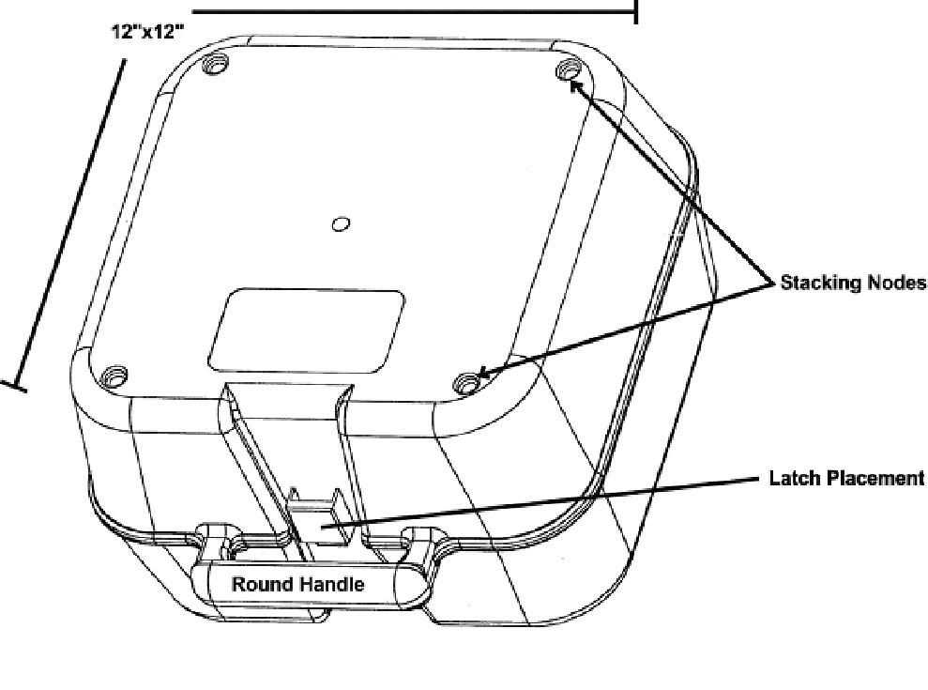

STYLING SPECIFICATIONS

BANDSMAN COAT: FOR: Bessemer City HS
Bessemer, AL

FABRIC: Xtreme Dri Raven Black (Synthetic blend), Xtreme Dri Passionate Purple (Synthetic blend)

STYLE: Hip length coat with a straight bottom. Back cut straight.

FRONT CLOSURE: Center front butted black nylon zipper.

SPECIAL DETAILS:
Fully constructed coat that allows the coat to be “Professional Laundered and machine washed”. The coat has performance-wear “Aerocool” lining for maximum breathability and comfort for the wearer. “Aerocool” lining is woven to absorb and evaporate moisture rapidly by capillary effect. The absorption, diffusion and evaporation system of this lining is designed to maintain cool body temperature and excellent comfort for the wearer. The coat also utilizes performance-wear canvas that is fully machine-washable. The coat has snap tape at the cuffs to allow for adjustable hems without the necessity of sewing. The sleeves are a special pattern that allows freedom of movement for the wearer. There are special pre-molded (3/4" thick) firm foam shoulder pads with nylon tricot covering measuring 5” wide x 9” long at each shoulder. The “Comfort Collar” utilizes eight layers of construction. The collar lining is Xtreme Dri fabric and has a non-woven material, permanently sewn and bonded to the inside. It is sewn directly to the inboard surface of this tandem collar lining construction, centered on the lining and running the circumference of the collar are two layers of 1/2” horse hair braid reinforcement. The outer collar shell, also made of Xtreme Dri, has a non-woven material permanently sewn and bonded to the inside. Both the collar lining construction and the outer collar shell construction are sewn to two base layers of heavy duty Pellon forming the finished comfort collar. Each coat has an identification number, as well as a barcode.

FRONT TRIM: Right side to be sublimated on Xtreme Dri Divine White to match special school gold at top to Black at bottom. Set on the right chest is a printed black “O” with a gold metallic looking printed outline. Left side to be Xtreme Dri Raven Black. Set on left front is a triangle applique of Gold Glamourous attached with Gold metallic satinstitch.

BACK TRIM: Xtreme Dri Passionate with ½” stripes of Xtreme Dri Black on edge body seams.

COLLAR: Xtreme Dri Raven Black with ¼” stripe of Xtreme Dri White set down ¼” from top.

SHOULDER STRAPS: Xtreme Dri Raven Black with ¼” stripe of Xtreme Dri White set in ¼” all around.

(Continued on next page.)

UPPER SLEEVE TRIM: Xtreme Dri Raven Black with pointed sleeve appliques of Xtreme Passionate Purple and ½” stripe of Xtreme Divine White set flush to bottom edge of appliques. Set in an arc on applique, ½ p.b. “THE MARCHING BAND” with “PURPLE & WHITE” set in revere arc below of all direct swiss with a 2 ½” tiger logo of white outline with purple fabric showing through.

CUFF: Xtreme Dri Passionate Purple - ALL AROUND: All Set at 4"x 6" x" 4" - a 1" PEAKED stripe of XD Passionate Purple. Butted to the top and bottom of the stripe is one row 527 white with the top row extending into a TRE-1 three loop trefoil. Set below stripe, 2" tiger paw print of White direct swiss.

STYLING SPECIFICATIONS

BANDSMAN JUMPSUIT: FOR: Bessemer City HS
Bessemer, AL

FABRIC: Xtreme Dri Passionate Purple (Synthetic blend)

OPTIONS: Fully Lined ____ One-Half (1/2) Lined ____
Adjustable Zipper ____ Hemmed ____
Side Pockets ____ Welt pocket ____
Flair Legs ____ Heel Guards ____
Suspender Buttons ____ French Fly ____
Front Zipper XXXX Back Zipper ____

STRIPE: 1” stripe of Xtreme Dri Raven Black with piped each side with white fabric piping.

POCKETS: Two as part of the fly.

SPECIAL FEATURES AND DETAILS:
Special “Racer Back style”. Identification numbers. 18” legs. 1 ¼” shoulder straps of jumpsuit fabric with nylon slides and black elastic in back of suspenders. Inseam sewn with 5/8” seams for let out. 4-way reinforced crotch. 3” let-out in center back. Snap tape is on back of seam allowance on the out seam and it is on the front side of the seam allowance on the inseam.

STYLING SPECIFICATIONS

HEADGEAR: FOR: Bessemer City HS
Bessemer, AL

STYLE: C-51” flat top shako
PLUMEHOLDER: Center Front
VISOR: Black
TOP MATERIAL: Xtreme Dri Raven Black
SIDE MATERIAL: Xtreme Dri Passionate Purple
BANDS: Both: Xtreme Dri Raven Black. Pipe top of bottom band and bottom of top band with white fabric
ORNAMENT: Centered on front, set diagonally, f.b. “BC” of white direct swiss with black outline.
CHINSTRAP: Black with a nickel buckle
FRONT CHAIN: B-336 Nickel
SIDE BUTTONS: 45L Nickel Dome Prong
SPECIAL TRIM DETAILS: Metal hook in back of shako for chinstrap. Vinyl I.D. pocket in top of shako.

ACCESSORIES:

SIDE CAPE: Xtreme Divine White. Lined in Xtreme Dri Passionate purple. Black machine snap to secure turnback’s. Centered on cape on white side, special f.b. design “MPW” attached with satin stitch.

PLUME #1: 12” White French Fountain – nickel cup

PLUME #2: 10” Black Mylar – nickel cup

GARMENT BAG: 200 Denier nylon with accessory pocket, clear vinyl ID window and one-color screen-print of school band logo.

SHAKO BOX: Black plastic Shako-Mate.

DEVIATION FORM
In the event that the undersigned Bidder intends to deviate from the specifications by utilizing any materials, items, treatments, finishes, inner construction, tailoring details, etc., contrary to those listed as standards in the specifications, the bidder is to fully document and list each deviation in complete detail including reasons for the deviation. General statements are not acceptable. Furthermore, these deviations are to be approved in writing.
If no deviations are submitted, the bidder assures the buyer of full compliance with the specifications and conditions, and assures the buyer that samples accompanying bid meet all construction specifications.
If deviations are found on said sample, and not listed, the bidder is to be disqualified!

Company_____________________________ Signed________________________
Date__________________________________ Title_________________________

BID FORM

TO:

ATTN:

BESSEMER CITY HIGH SCHOOL BAND UNIFORMS
Item# | Item | Quantity | Unit Cost | Extended Cost
1 | Band Coat | 98
2 | Band Jumpsuit (Bibber-Trouser) | 98
3 | Band Shoulder Drape | 98
4 | Band Headgear | 98
5 | Band Plume | 98
6 | Drum Major Cape | 2
7 | Drum Major Headgear (Busby) | 2
9 | Drum Major Coat | 2
10 | Drum Major Bibbers | 2
11 | Garment Bag | 100
12 | Shako Box | 100
 |  |  | Total

TERMS:
If awarded the contract, we agree to ship a sample uniform within ____ days and to ship the entire order within approximately _____ calendar days after approval of sample and receipt of necessary details and measurements.

Company: DATE:
Address:

Telephone: ____________________________________
Signed By/Title

